Scrabble
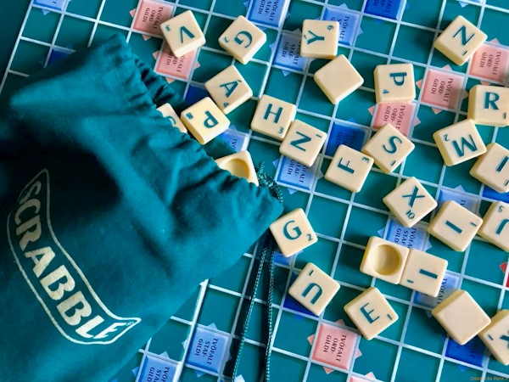
Description: A board-and-tile game where players form words with lettered tiles.
How to Play: Players take turns creating words on the board to score points. The player with the highest score wins.
Location: Indoor
Things Needed: Scrabble board and tiles
Number of Players: 2 to 4

